In keeping with the holiday theme, use the Decorator design pattern to model a Christmas tree as a base component (the tree) and optional decorations or adornments such as bulbs, candy and garland. Initially it's enough for your solution to model just the printing or display of the tree along with its adornments. You can also assume that each type of decoration is added all at once.

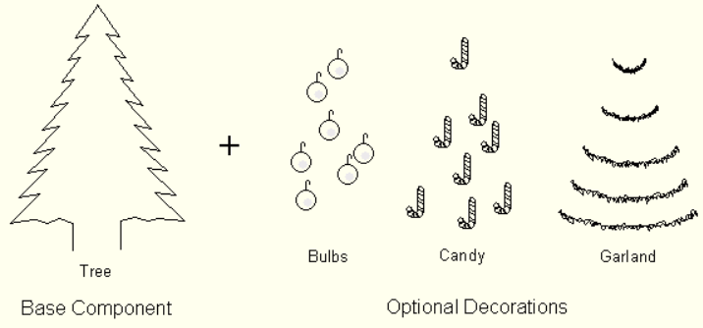

*Problem:* Show the class diagram for your solution